How To Build
‘The Menai Bridge’
In Meccano
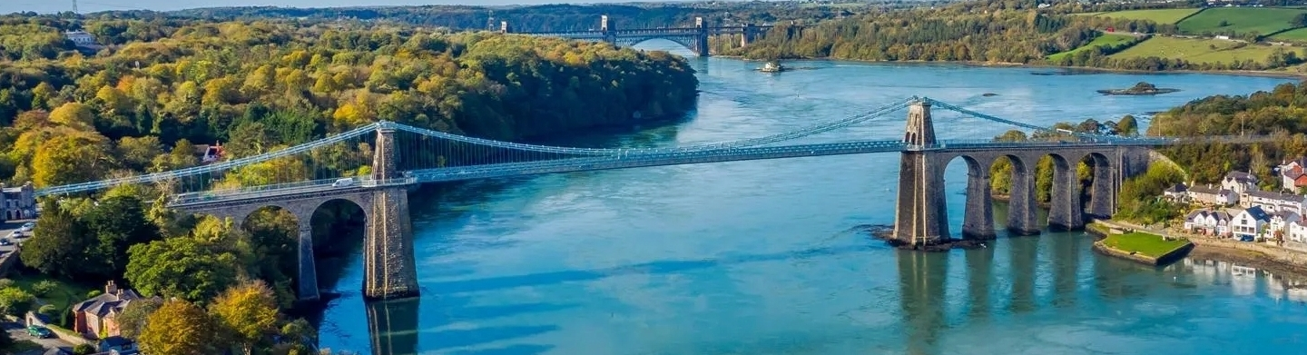
By John Thorpe

Inspiration

Having spent many camping holidays in Anglesey I had crossed over the Menai Bridge many times - I started my canoeing career in Anglesey in the late 1970s and finally circumnavigated the island (80 miles) by canoe with my late friend John Knight.
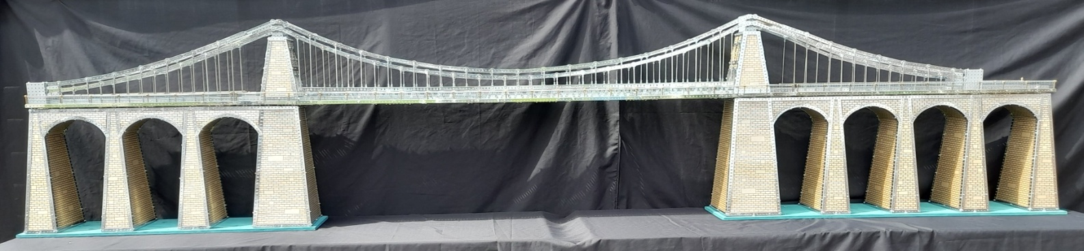
The Menai Bridge was built in 1826 so is now celebrating its 200 Year Anniversary (a big coincidence that I choose this year to build it) – it was built to connect North Wales to Anglesey so that politicians from Northern Ireland could get to London by coach via the port of Holyhead.

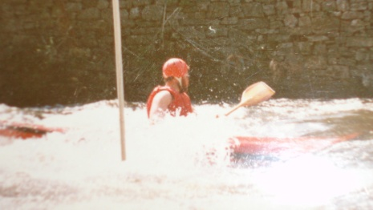
The Menai Straits is a treacherous bit of water (tidal) – the tides come up the Menai Straits from both directions (east and west) and meet roughly at the Menai Bridge - I well remember taking 2 of my star canoeing pupils on the straits and watching them both capsize – they were 200 metres away when I finally saw them!

Introduction
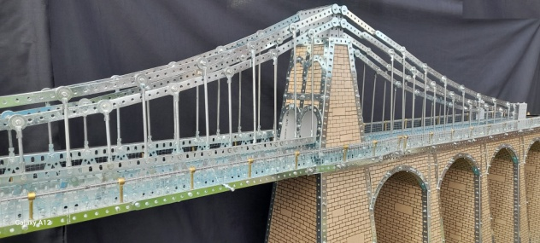
The Menai Bridge was one of the first suspension bridges in the world – it is 417m (1368’) long with a span of 176m (577’) – it is 12m (39’) wide and the clearance to the Menai Straits is 31m (102’) – 200 years ago there were only sailing ships around which needed this much clearance for their tall masts.
The big problem was the large number of 2.5” narrow strips, 4.5” strips, large washers, rod and strip connectors (both normal and RH) that would be needed for the main span – re-zincing was not a problem as my zincing firm (AllenChrome) are brilliant. Long girders supplied by my good friend Bernard Garrigues in France.
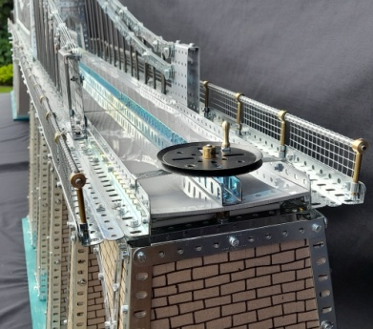
The Roadway
The Roadway was to be grey perspex so that vehicles could run back and forth along 2 channels – flat girders along the sides and long girders in the middle of the Roadway ensured that no bolts protruded which would hinder the vehicles travelling along – the initial plan was to motorise the travelling mechanism but a simple hand winding mechanism proved a success – vehicles are fastened to the cord using coloured rubber bands!
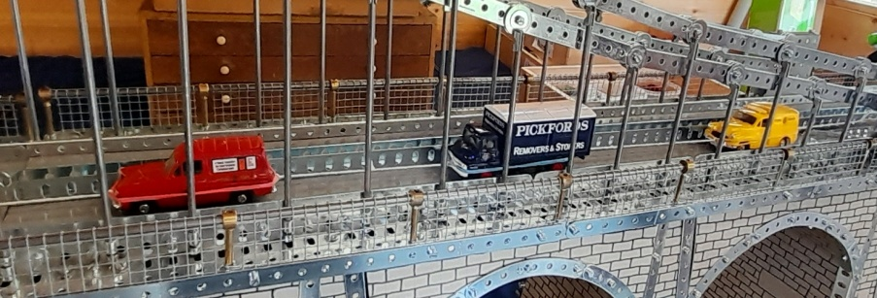

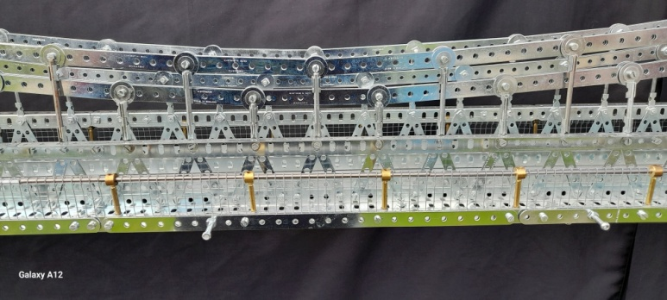
The Pathway
The Pathway needed a Fence so ¼” wire mesh was used wrapped around long axles at the top – supported by collars and brass rods to the deck using RH rod and strip connectors.
The starting point for the model was the criss-cross effect using 2.5” narrow strips bolted onto long girders both top and bottom – these were joined together using 5.5”x3.5” flat plates – these were powder coated in light gray to match the colour of the Roadway – my local powder coating firm (Scunthorpe Powder Coating) were brilliant at this.

The Towers
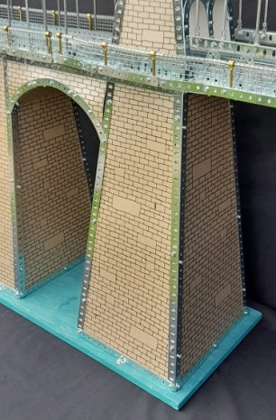
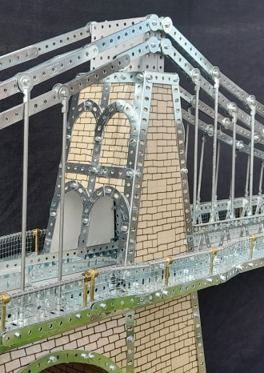
The Towers needed a brick effect to fill them in but I could not find any suitable material so I made my own using coloured card and a black felt tip pen – this took a lot of effort, time and patience.
The smaller Towers over the Roadway had similar brick effect to fill them in – archways were constructed to allow vehicles to pass through – I bought a selection of cars, buses and lorries and made sure they passed through the archways.
The whole model was bolted down on to sheets of plywood which greatly improved the rigidity – painted in poster paint.

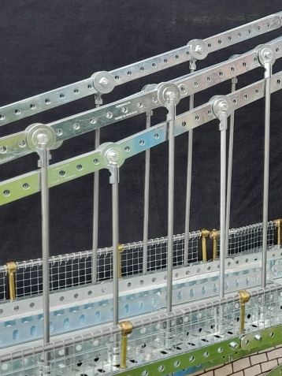
The Suspension Chains
The Suspension Chains units were each made using 3 x 4.5” strips bolted together in a long line – joined using 4 large washers and 0.5” bolts for effect – the suspension rods were connected to the Roadway with rod and strip connectors on the top right angled ones on the bottom. The tricky part was to connect the suspension chains of the 3 sections of the Bridge together – this eventually proved easy as there is plenty of ‘play’ in the lengths of the suspension rods which alters the length of the suspension chains – a ‘drift’ comes in useful here.

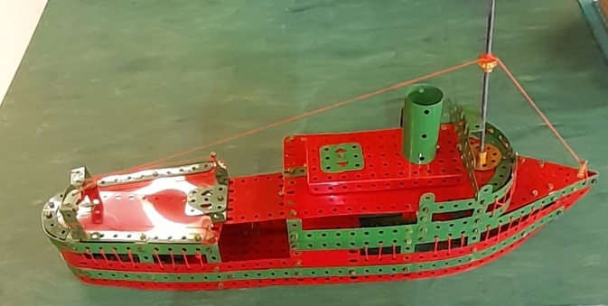
The Steamer and Menai Straits
Finally what the model needed was water under the bridge and a boat travelling under it – the Water or Menai Straits was made using thin MDF board painted with poster paints – the Steamer was a No 5 set model made from my bestest red and green Meccano- what a pleasure it was to spent 2 days building this model (I was 9 years old again!) – the manual however was rubbish and totally inaccurate.
Apologises for any lack of consistency in scales – the Steamer is too big and the span is too short.

