***How To Build***

***‘A EUROFIGHTER’***

***In Meccano***

***By John Thorpe***

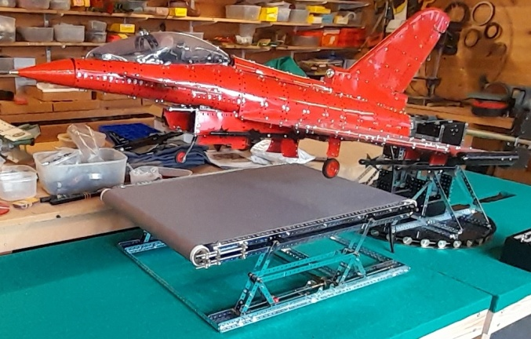

***Introduction* - *Why build a Eurofighter? – You may remember my ‘Tornado’ back in 2006 at Bellegarde and Skegness – Well how do you top that? – Long in my mind was to have the model not just ‘barrel roll horizontally’ but to raise up vertically - and even fly left and right – Well how do you raise up a 15/20 kgs model?***

***My enthusiasm also comes from the fact that my son actually used to fly a Eurofighter (RAF) – hard to imagine your son taking off and going vertical in a Eurofighter – then flying at Mach 1.8 (2223 km/hr or 1400 mph) and at 55000 ft – in a ‘tin can’ only 16 meters long with 11 metres wingspan weighing 10,000 kgs empty and 21,000 kgs fully loaded.***

***I also wanted to incorporate a moving runway which raises up and down simulating take off and landing.***

***Other features include landing lights and an array of weapons.***

***All parts were powder coated in red and black by Scunthorpe Powder Coating (thanks).***

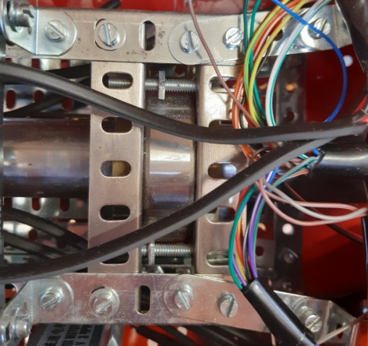***Planning***

***To raise my model vertically needed a pivot mechanism mounted on a tower 12” high – a 5 ft solid brass rod 1” diameter with 14 kgs of lead balance weight at one end and the model at the other end – a steel rod proved too hard to drill.***

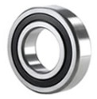

***Then to rotate the model around the brass rod needed a steel sleeve over the brass rod with 2 commercial bearings secured to the model’s chassis in a cage of angle girders – the steel sleeve is locked to the brass rod with a pin thus allowing the model to rotate around the steel sleeve inside the bearings.***

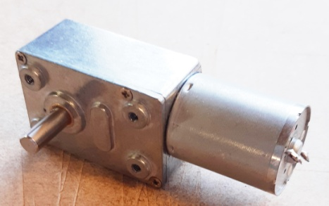***There are 10 motors inside the model driving all the mechanisms – namely cockpit, cockpit flaps, front and rear wings flaps, tail flap, front wheel and door, main wheels and doors and finally the model rotation – are all powerful 12 volt ones with speeds between 2 rpm and 5 rpm – this means no excessive ‘gearing down’ is necessary inside the model which cuts down the overall weight of th***

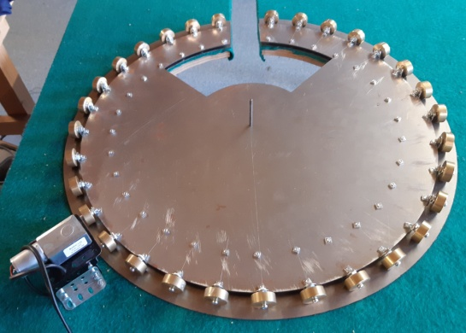***The Tower***

***To turn the model left and right the tower is mounted on a 21” diameter roller bearing – the roller bearing plates were made by Model Engineers Laser – I turned 32 x 1” wheels on my lathe (3/8” thick) – there was no rim on the plates as with a traditional roller bearing – friction was very low***

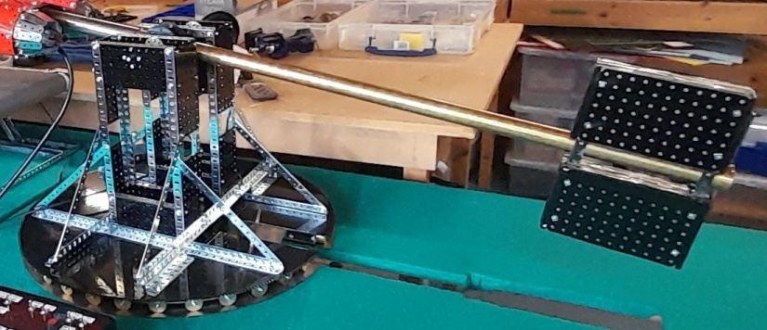

***I made the benches with a slit in to allow the lead balance weight to move through and under the table thus raising the model almost vertically at the same time as turning it left and right. The brass rod needs to be inside the opening on the roller bearing thus allowing 180 degrees of turning – hence to cut out shape***

***The balance weight was 14 kgs of lead sheeting neatly sandwiched between flat plates.***

***The tables are covered in green felt to simulate grass.***

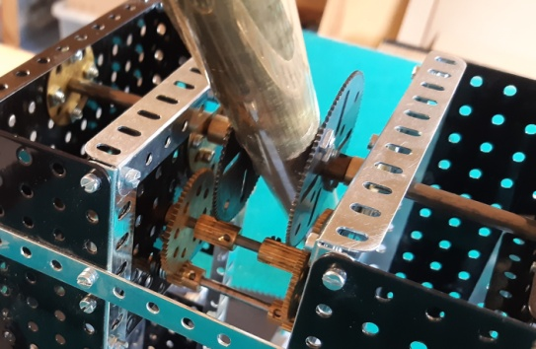

***The brass rod is pivoted on a 6mm steel rod housed in brass wheel discs – 2 x 2.5” gears are bolted to the brass rod and a dual gearing down mechanism links to another motor. Little effort is needed to raise and lower the model as it is well balanced.***

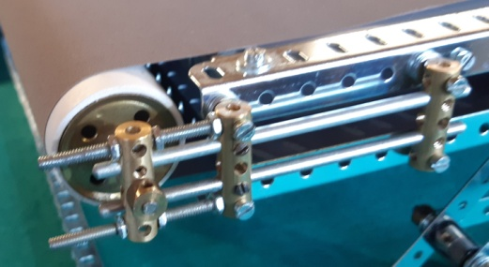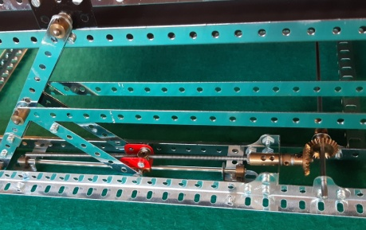***The Runway***

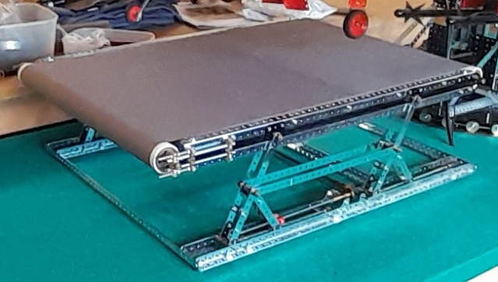

***A runway seemed the ideal way to simulate ‘take-off’ – a simple mechanism raises the runway up and down using a threaded coupling on a screwed rod - the runway itself is grey roller blind material which rests on a Perspex sheet and is rolled along over rollers at either end – the rollers are plastic waste pipes – adjusters are needed at one end to keep the runway running straight.***

***The Chassis***

***Consisted of 4 x 24.5” angle girders locked rigid at both ends with a commercial bearing housed in more girders – the bearings was just over 1” internal diameter so the steel sleeve could fit inside it – and the 1” diameter brass rod fit inside the sleeve - 1” diameter brass pivot rod could fit inside and rotate inside the model – thus allowing the whole model to rotate around the steel sleeve as the pivot rod is fixed to the tower – a 2.5” gear wheel was secured to the steel sleeve and a motor fixed to the model.***

***The Wings***

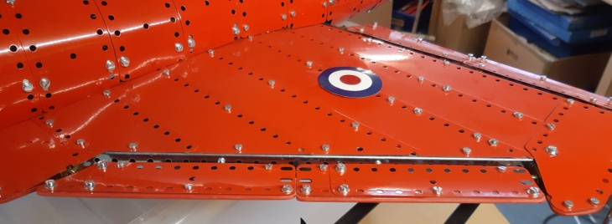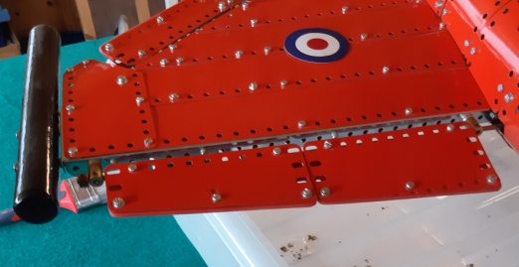

***Again consisted of angle girders bolted to the chassis and slightly raised – with a curved profile on the top and a flat bottom incorporating the main wheel mechanisms***

***Front and rear wing flaps are fitted on long axles – the axles are located in threaded couplings – these have red plastic edges for neatness – these are operated by 2 more motors – special 5/8” bevels were used (made by Stuart Borrill) to connect the motors to the axles – 7/8” bevels are too bulky and heavy***

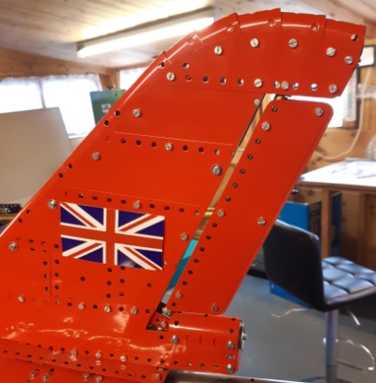***and 0.5” bevels have too much ‘play’ in them.***

***The tail flap is similarly constructed with a motor actually secured inside the tail fin.***

***The outside fuel tanks and weapons under the wings are all made from wood – painted with black enamel paint.***

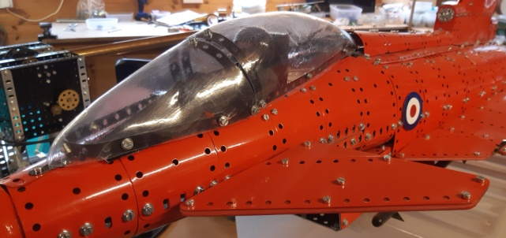

***The cockpit flaps are similarly constructed – mounted on a single axle and operated by another motor.***

***The Cockpit***

***This was the fun part of the model – with no experience of vacuum forming I made 2 moulds from Plaster-of-Paris – then made a vacuum box which is essentially a wooden box with loads of holes in the top – fitted to a household vacuum cleaner in a hole at the side – then heated plastic sheets in my oven and quickly placed them over the moulds – the vacuum sucking the plastic to the moulds – not a fantastic finish but at least I had a go! – a lever mechanism opens and closes the cockpit attached to yet another motor.***

***The After Burners***

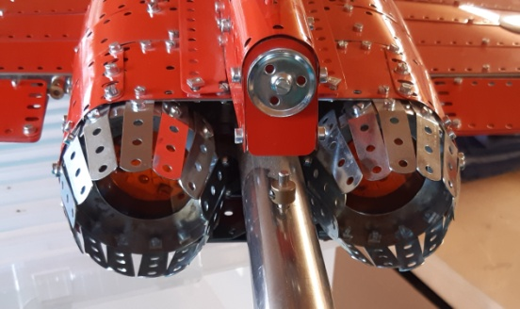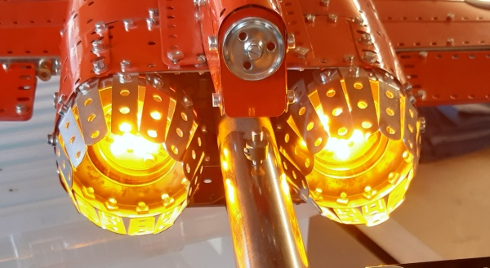

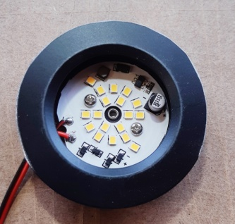***2 x 12 volt LED lights are fitted inside a 3” flange ring and 2” strips make the funnels for the exhaust – These LED lights are much lower in power than ones used on my Tornado – a dimmer circuit turns them on***

***and off – built it myself!***

***The Control Box***

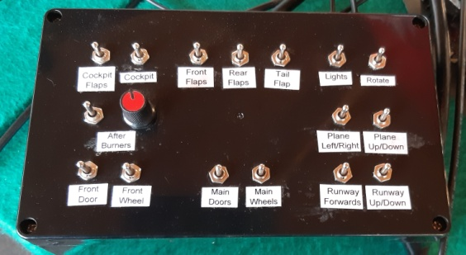

***All the 10 motors, lights and after burners were wired up using a 25 multicore wire i.e. 24 wires needed leaving 1 spare! – this was wired to the control box – this used DPDT switches so that motors could be reversed – a 12 volt lead acid battery was used to power the whole model thus no need for mains electricity.***

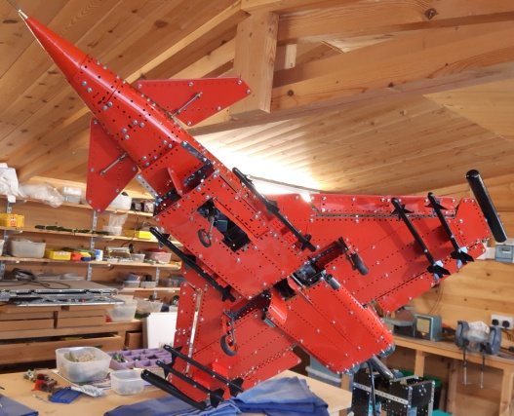***The Undercarriage***

***This spectacular photo (left and my favourite) shows how the model both lifts up and rotates.***

***There are 2 main wheels built into the wings which lower through 90 degrees again using a motor – the wheels fit into couplings and are linked together with rods and 5/8” bevel gears - with the wheels on the moving runway they rotate until take off.***

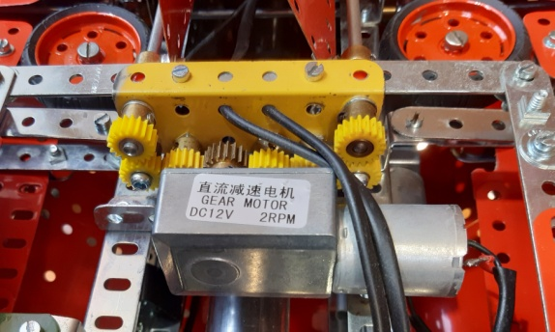 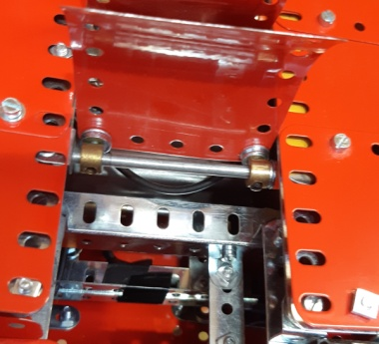

***The front wheel also lowers through 90 degrees and has its own door.***

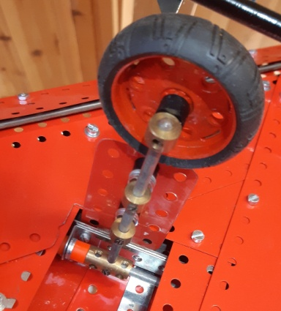***The 2 main wheels are built inside the wings and doors close to conceal them – the wheels fit into couplings and linked together with rods and 5/8” bevel gears***

***a motor lowers and raises the wheels with another motor opening and closing the doors.***

***each has a door which are operated in unison by a motor***

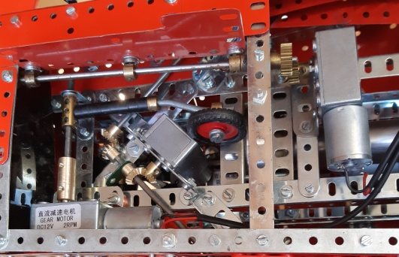 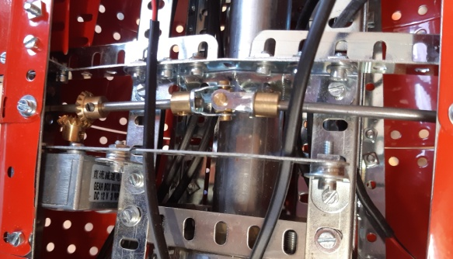

***The left photo above shows the mechanism for the front flaps on the wings – the 2 rods holding the front flaps meet at approx 90 degrees using the 5/8” bevel gears previously mentioned and a motor – the right photo above shows the mechanism for the rear flaps on the wings – the 2 rods are now linked by a universal coupling – more 5/8” bevels and a motor.***

***Diecast Model***

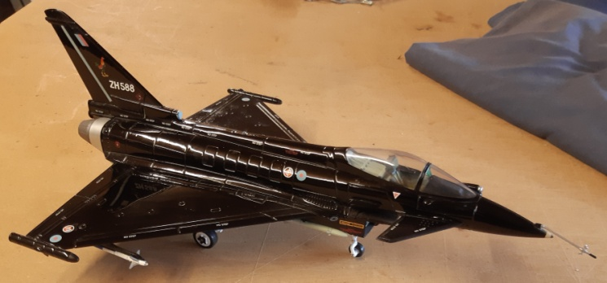

***This ‘toy’ was very useful to visualise the model and to take initial measurements – the starting point was the wheels – 1” and 1.5” Meccano tyres proved ideal – the rest just grew and grew!***