Oxton Meccano Gathering - 25th April 2026
Model Reports
Apologises for any mistakes – please let me know
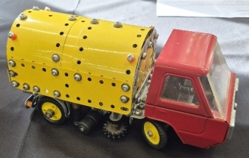
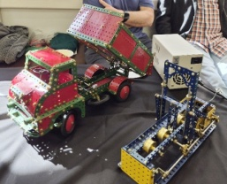
John Ozyer-Key – SML Log Saw (1978 dark blue and yellow) – Thames Trader Tipper Truck (mint 1950s medium red & green) – Mogol Cab Road Sweeper (French yellow – Bernard Perier in CQ)
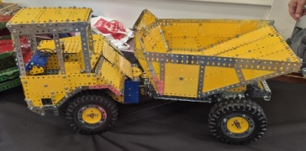
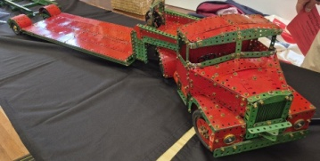
Richard Dunster-Sigtermans – JCB Articulated Dump Truck – Modelplan 117 designed by Tony James – (Set 10+ in 1970s) – Scammell Highwayman & Low-Loading Semi Trailer
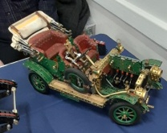
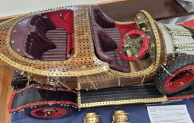
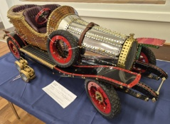
Doug Hedgley – 2 models of ‘Chitty Chitty Bang Bang’ & Armstrong 1907 – based on outline drawing – larger model half finished at present – more details to follow – my favourite model of the meeting
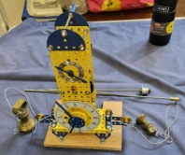
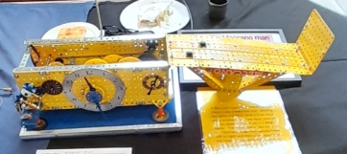
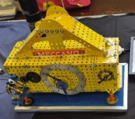
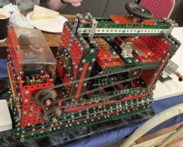
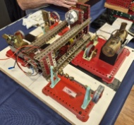
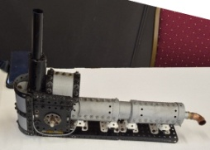
John Ansell – Strip Plate Bending Machine – Mamod Steam models – Early Meccano Lathe – Modern Steam Boiler – Model Transformer
Raymond Mee – 2 Yellow Clocks – mains or battery operated – very neat models
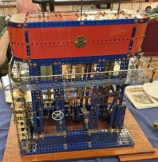
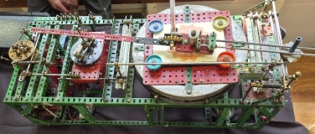
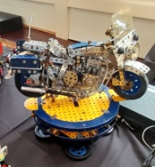
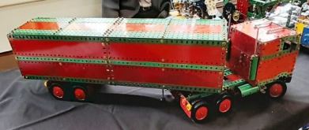
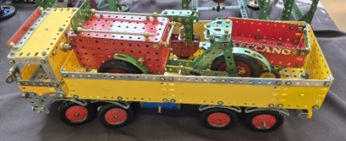
Les & Les Nightingale – Meccanograph in Red & Green (winner of ‘Bestest Model’ competition) – Police Bike in dark blue & zinc – 8 Wheeler Truck ERF in yellow & zinc – Tricycle Delivery Truck in Red & Green – Market Gardeners Truck?
Mark Rolston – Triple Expansion Engine – Built by the late Martin Packer

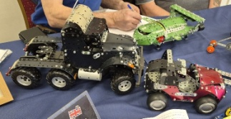
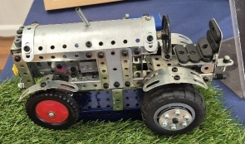
Chris Harris – Thunderbird 2 – Ducati Tractor – Motor Bike – M & S Design Truck
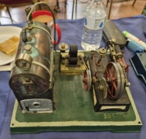
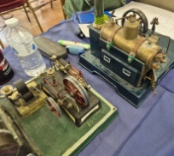
Colin Reed – Bing & Doll Steam Engines – around 1920’s – rare German engines – part of his 30+ collection

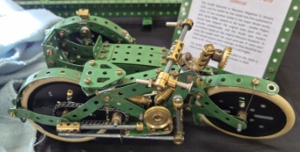
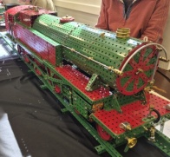
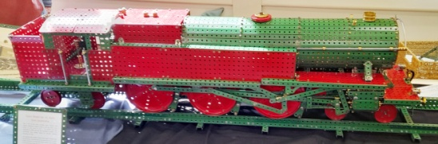
Andy Robinson – Baltic Tank Loco – Super Model (No15) from in 1950s – red & green with a 20 volt motor - Motor Bike & Sidecar - reproduction of a 1920’s Super Model (No 3) using reproduction 3” tyres
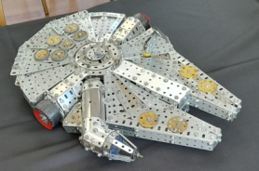
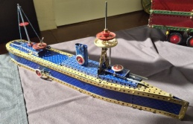
John Nuttall – Exploding Ship – model 7-10 from 7/8 manual – built in blue & gold – exploding mechanism was modified from a rubber band to tension springs
Greg Webb – Philip Webb’s Millenium Falcon – Han Solo’s & Chewbacca’s ship from ‘Star Wars’
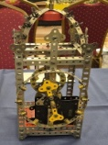
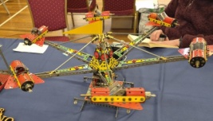
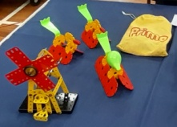
John Bader & Carola – Nuremburg Clock by Pat Briggs from 1970’s magazine – Jet Aeroplane Roundabout from 1960’s magazine based on a dealer’s display model – Windmill built by partner Carola from 1960’s No 1 outfit – Duck and 2 Ducklings built in Prima
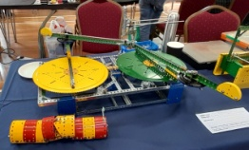
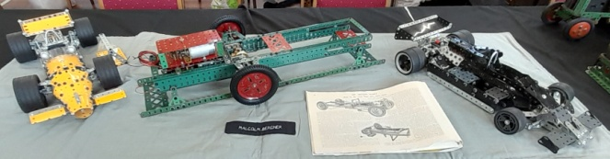
Malcolm Bergner – Lotus Race Cars – Motor Chassis 1934 to be built up as Rumpler – front wheel drive HGV delivering newspapers to Berlin late 1930s
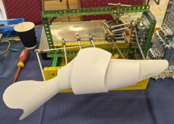
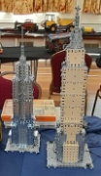
Alan Bendall – Mechanical Fish – Katy The Caterpillar – 2 x Empire State Buildings by Spin Master – 2 Roller Bearing Plates? (supplied by John Thorpe)
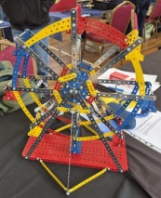
John Gerard Duffy – Ferris Wheel – from the Ferris Wheel set – made in China under licence – 1994 to 1997
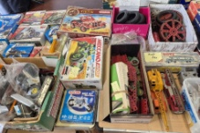
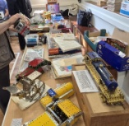
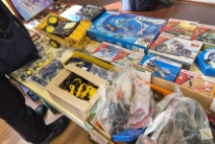
Mick Burgess – Motorway Coach in red, black & zinc – Saloon Car in red & green – Printing Machine in nickel – Streamline Petrol Tanker – Pacific Tank Loco in blue & gold – Stuff for Sale
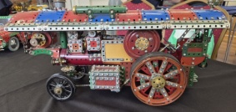
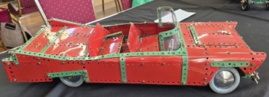
Tim Martin – Sports Car built by Mick Burgess – Traction Engine built by Ernie Chandler
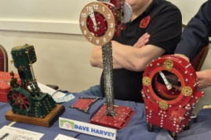
Dave Harvey – Gravity Powered Clock self powering as the clock drops down the tower under gravity – Holo Clock with no mechanism that makes the hands look like they are floating in mid air – Inverted Vertical Steam Engine from Bert Love book with extra features ie flanged wheel valve, governor, & pressure gauge
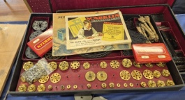
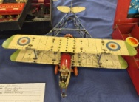
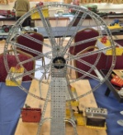
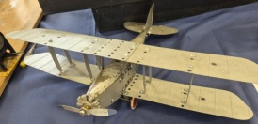
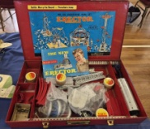
Peter Harris – Meccano Alternatives – Gilbert (USA) – Markin (Germany)
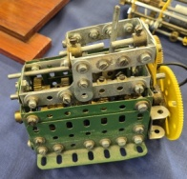
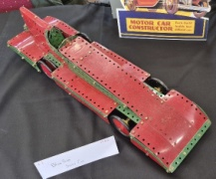
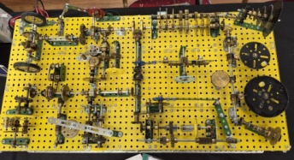
Matthew Shaw – Gears Demonstration Model – using all gears from post-war Binns Raod – Intermitant Drive Forward & Reverse – Differential with Wheel Braking – 3 Speed & Reverse Gear Box – Blue Bird
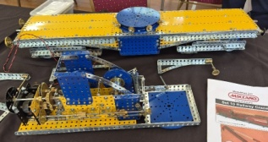
Gerarde Nixon – No 10 Set Railway Crane by Tony Parmee – Tony redesigned many No 10 Set models, staying within the parts restrictions, but vastly improving on the originals
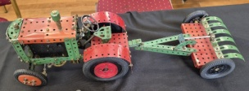
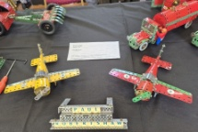
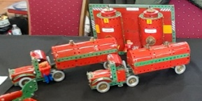
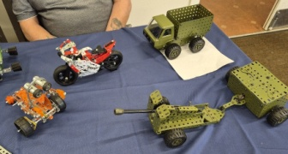
Paul Robertshaw – 2 Articulated Tankers + Loading Bays – 2 Small Planes – Clockwork Tractor with Trailer - Freelance Mill Engine
Bernard Lamb – Army Truck – Army Field Gun with Ammunition Trailer – Motor Bike – Buggy

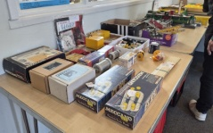
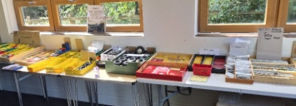
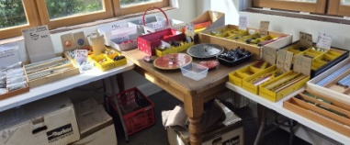
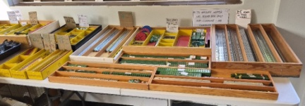
Traders Tom & Matthew McCallum
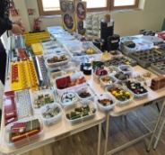
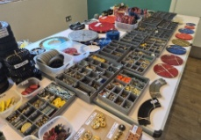
Trader Rob Thorpe

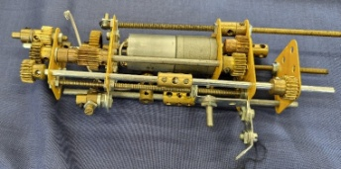
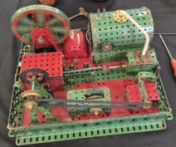
Photos of Unknown Models – Please e-mail me in you can identify any
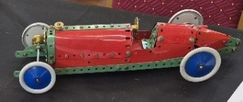
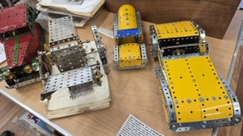

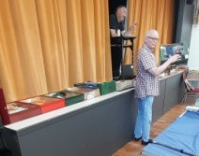
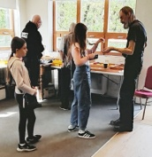
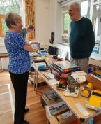
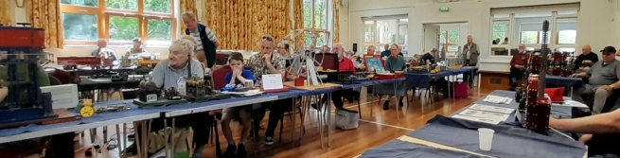
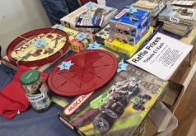
Raffle Prizes – Hall View – Auction – Ava Hard Selling – Mike Chatting Up Linda

